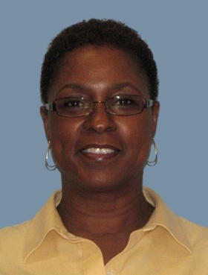
Laquetta Odum
Senior Financial Analyst
Columbus, Ohio

Laquetta is an employee of NiSource/Columbia Gas located in Columbus, Ohio. Laquetta’s service with NiSource has extended over 30 years in various positions within the Accounting and Finance departments.
Laquetta’s current responsibilities include preparation of monthly, annual and five year forecasts for Columbia Gas of Ohio’s Operations and Maintenance (O&M) budget. Additional responsibilities include the analysis and reporting of budget to actual variances; the compilation and submission of Natural Gas Distribution (NGD) Consolidated O&M reporting and departmental collaboration with Accounting, Regulatory and Financial Planning to ensure accurate and timely operating expenses to be used in financing activities and/or regulatory filings.
Laquetta has been a member of AABE since 2009 and currently serves on the Board of Directors; Finance & Scholarship Committees.

