JOHN R. SMITH
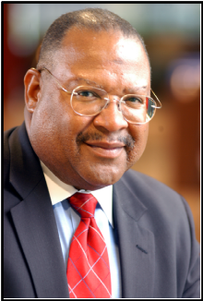
John R. Smith was appointed Director - Corporate Responsibility for Public Service Electric and Gas Company (PSE&G), effective May 2005. In this position, Mr. Smith is responsible for the development and implementation of corporate strategy, policy and initiatives for corporate contributions; executive and employee-giving programs, corporate memberships, sponsorships and events management. He also serves as the president of the PSEG Foundation, and directs the company’s investments in three key areas of philanthropic priority – children and family issues, community and economic development, and the environment.

During Mr. Smith’s employment with PSE&G, he has held various positions in operations, information technology, internal auditing, and external affairs.

Mr. Smith attended Lincoln University in Oxford, Pennsylvania, and holds a Bachelor of Science degree from Fairleigh Dickinson University. He has also completed the Executive Management Program at the Smeal College of Business Administration – Penn State University. He is a certified mediator through the Cornell University School of Industrial and Labor Relations, and U.S. EEOC, New York District Office.

Mr. Smith has received numerous awards, citations and honors. Recently he received the National Conference for Community and Justice (NCCJ) “Community Service Award,” and was honored by the Urban League Guild for Bergen County. He is a 1996 “Leadership New Jersey” Fellow.

Mr. Smith has served in executive board positions in over 50 civic, community-based, fraternal, education, business, and professional not-for-profit boards throughout North Jersey. He is currently the chairman of the Commerce and Industry Association of New Jersey, and serves on the boards of the Hispanic Institute of Research and Development, Hackensack University Medical Center Foundation, Meadowlands Regional Chamber of Commerce, and the Bergen Catholic High School Board of Trustees. Mr. Smith is the former Secretary of the Bergen Community College Board of Trustees, and served on the National Board of the American Association of Blacks in Energy.

